Upper Columbia Swallow Habitat Enhancement Project
Year 3 (2023-2024)
Large Grant - Final Report Project Number: COL-F24-W-3807

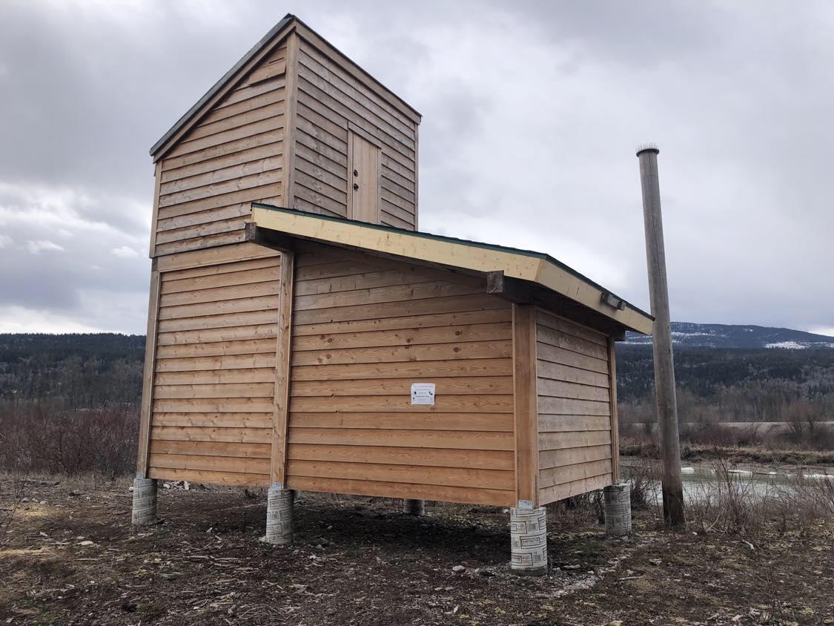
Prepared for: Fish and Wildlife Compensation Program

Prepared by: Rachel Darvill, B.Sc., M.Sc., R.P.Bio
Goldeneye Ecological Services
racheldarvill@gmail.com
Contract biologist to Wildsight Golden

Prepared with financial support of the Fish and Wildlife Compensation Program on
behalf of its program partners BC Hydro, the Province of BC, Fisheries and Oceans
Canada, First Nations and public stakeholders.

29-MARCH-2024

Executive Summary
Avian aerial insectivores (e.g., swallows, flycatchers, nightjars) have experienced the steepest population declines of any group of birds in Canada. The Upper Columbia Swallow Habitat Enhancement Project (UCSHEP) is a five-year (2021-2026) initiative using a multi-faceted approach to conserve and enhance two at-risk species - Bank Swallow (Riparia riparia) and Barn Swallow (Hirundo rustica). The main overarching goals of UCSHEP are: a) create and enhance breeding areas, b) complete effectiveness monitoring at all enhancement sites, c) build increased awareness for swallows including Indigenous perspectives, d) coordinate citizen-scientists to inventory/monitor swallow nests, and e) participate in Motus Wildlife Tracking to learn about Bank Swallow migration routes and important areas outside their breeding range.

There are a number of cumulative factors responsible for significant population declines of aerial insectivores, including widespread pesticide use, population decline of aerial insects, climate change, collisions with vehicles, and the loss of breeding, foraging and winter habitat. To increase habitat availability for at-risk swallows, the UCSHEP erected seven artificial nesting structures (ANSs) including a structure built to satisfy habitat requirements for bats and swallows, installed nest cups on pre-existing structures, enhanced and expanded Bank Swallow habitat in Invermere and near Parson, and is collaborating with partners to create the first artificial nesting structure for Bank Swallows in western Canada. Effectiveness monitoring has and will continue to occur at all enhancement and restoration sites.

Monitoring natural and artificial nest sites is providing information about the distribution and abundance of Bank and Barn Swallow species in the Columbia Valley study area. In 2023, 82 people volunteered to monitor swallows, with 125 volunteers participating since 2021. The UCSHEP has identified 171 swallow colonies in suitable Bank Swallow habitat (e.g., near vertical slopes, friable soils) from Canal Flats to Donald; 115 of those have been confirmed as Bank Swallow colonies. Barn Swallow nests have been discovered on 113 structures at 62 unique locations. All swallow monitoring data was submitted to the provincial data warehouse (Wildlife Species Inventory – WSI). UCSHEP data is being used for potential Key Biodiversity Area (KBA) status, has contributed to the development of wildlife corridors through Kootenay Connect, development permit applications, and will assist with future expansion of Bank Swallow critical habitat under the Species at Risk Act.

The UCSHEP has also participated in the Motus Wildlife Tracking initiative. Through a collaboration with Environment and Climate Change Canada’s Canadian Wildlife Service (ECCC CWS) and other partner groups, three large (Yagi) and three small (omni-directional) Motus Wildlife Tracking Stations were installed in the study area. In 2023, Bank Swallows were tagged with miniature digital radio transmitters (Motus tags) at two colonies near Invermere [Wilmer and Shuswap Band land (Secwépemc Nation)]. The data is being analyzed by a student for her Master’s thesis, providing unprecedented information on Bank Swallow post-breeding habitat, their migration route, and wintering grounds.

Outreach was aimed towards conserving swallows and their habitats, attracting volunteers for swallow monitoring and directing habitat enhancements on private land. Strategies to co-exist with swallows were widely promoted and the UCSHEP communications strategy included posters, videos, website/social media content, press releases, interpretive signage, a swallow conservation brochure, hosted booths at farmer’s markets and gave presentations on the project. Additional education and outreach activities occurred, such as five volunteer field training sessions and two field trips.

This project most closely aligns with the Wetland and Riparian Action Plan, priority action 37. This is a habitat-based action working on enhancing wildlife habitat features (for swallows). Secondarily, the project most closely aligns with the Rivers and Riparian Action Plan, priority action 6. This is a habitat-based action working on the connectivity of habitat for both Bank and Barn Swallows. These two FWCP actions have the highest level of priority (number one) within the FWCP action plans.
Suggested Citation:

Darvill, R. 2024. Upper Columbia Swallow Habitat Enhancement Project - Year 3 (2023-2024). Large Grant - Final Report. Project Number: COL-F24-W-3807. Prepared for the Fish and Wildlife Compensation Program by Goldeneye Ecological Services.

Prepared by:
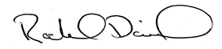
Rachel Darvill, BSc., MSc., RPBio
Goldeneye Ecological Services
racheldarvill@gmail.com

Cover photo: Parson Air B&B, habitat compensation for endangered bats and threatened birds (swallows).

Table of Contents
Executive Summary 1
List of Tables 5
1.1 Background 6
1.2 Bank Swallow 6
1.2 Barn Swallow 7
1.3 Motus for Bank Swallows 7
1.4 Statement of project need 8
2.0 Goals and Objectives and Linkage of FWCP Action Plans and specific 10
Action(s) 10
3.0 Study Area 10
4.0 Methods 11
4.1 Project start-up 11
4.2 Field Work 11
4.3 Data collection 12
4.3.1 Bank Swallow inventory and monitoring protocol 12
4.3.2 Barn Swallow monitoring protocols 13
4.4 Data entry and analysis 14
5.0 Results and Outcomes 14
5.1 Bank Swallow 14
5.1.1 Motus Wildlife Tracking – Bank Swallows 23
5.2 Barn Swallow 24
5.3 Outreach and Education 26
5.4 UCSHEP Enhancement and Restoration Projects 26
5.4.1 Number of hectares enhanced 30
6.0 Discussion 30
7.0 Recommendations 31
8.0 Acknowledgements 32
9.0 References 33
10.0 Appendices 36
10.1 Appendix A. Newspaper article on the swallow/bat artificial nesting structure in The Golden Star in July 2023. 36
10.2 Appendix B. Article in The Golden Star newspaper about the completed Bank Swallow enhancement project in Athalmer. 37
10.3 Appendix C. Poster developed for distribution at a wood mill in Golden with a high population of breeding Barn Swallows. 38

Table of Figures

Figure 1. Map with Bank Swallow colony locations and federally designated Critical Habitat in the study area………………………………………………………………………………………………………………………………………………………… 9
Figure 2. Active Bank Swallow colony discovered at Athalmer Neighborhood Park in 2021………………… 17
Figure 3. Vehicles and boat trailers parked within 25 meters of Bank Swallow colony in Athalmer……… 17
Figure 4. Substrate pile in Athalmer before resloping to expand suitable Bank Swallow habitat; active colony area on left hand side of pile……………………………………………………………………………………………………… 18
Figure 5. Substrate pile in Athalmer after resloping work had been completed by heavy machinery……. 18
Figure 6. Signs installed on fence that was put up to inform the public of the importance of the sensitive nesting habitat in Athalmer………………………………………………………………………………………………………………….. 19
Figure 7. Interpretive sign installed at the Athalmer Bank Swallow colony in Invermere………………………. 19
Figure 8. Sunbathers and moored boat in front of active Bank Swallow colony at Lake Windermere in June 2023. Colony circled in black………………………………………………………………………………………………………… 20
Figure 9. Abandoned Bank Swallow colony above foreshore development at Lake Windermere. Colony circled in black………………………………………………………………………………………………………………………………………. 20
Figure 10. Bank Swallow breeding habitat at Lake Windermere Provincial Park; a) before restoration and b) after…………………………………………………………………………………………………………………………………………………. 21
Figure 11. Mini Motus (Omni) stations installed at The Nature Trust of BC properties:, a) Columbia Lake North Wetlands property, and b) Hoodoos property…………………………………………………………………………….. 22
Figure 12. Artificial nesting structure for Barn Swallows built in Golden in 2023. 12' x 18' with slanted roof and low amount of openness………………………………………………………………………………………………………… 24
Figure 13. Parson Air B&B - an artificial nesting structure for bats and birds (swallows), located in Parson adjacent to the Columbia River within the Columbia Wetlands Wildlife Management Area…………………. 24
Figure 14. Map showing the locations of enhancement projects completed or in progress………………….. 26

List of Tables
Table 1. List of UCSHEP enhancement projects, completed or in progress……………………………………………. 27
Table 2. List of UCSHEP enhancement projects, completed or in progress (con't)…………………………………. 28

1.0 Introduction

1.1 Background
Approximately 2.9 billion birds have disappeared in Canada and the United States since 1970, a population decrease of 29 per cent (Rosenberg et al., 2019). Birdlife International’s (2022) State of the World’s Birds report states “data from the IUCN Red List show that 49% of bird species populations worldwide (5,412) are declining, while 38% (4,234) are stable, just 6% (659) are increasing, and 6% (693) have unknown trends.” Avian aerial insectivores (birds that forage while flying such as swallows and flycatchers) have been suffering large population declines for decades (Nebel et al., 2010). They have experienced the steepest population declines of any group of birds in Canada (North American Bird Conservation Initiative Canada, 2019). Multiple synergistic factors are contributing to this decline including the global decline in insects (prey), habitat loss, climate change, and changing conditions on migratory habitat or stopover grounds (Spiller & Dettmers, 2019). To help reduce and recover at-risk swallow populations, biologist Rachel Darvill with Goldeneye Ecological Services developed and manages the Upper Columbia Swallow Habitat Enhancement Project (UCSHEP) (2021-2026), a project administered by Wildsight Golden.

1.2 Bank Swallow
The Bank Swallow (Riparia riparia) is facing one of the fastest population declines for a single species in Canada with an estimated 93%-98% population loss in Canada over a forty-year period (Smith et al., 2020; COSEWIC, 2013). In 2013, the Bank Swallow was listed as a Threatened species by COSEWIC and was listed as Threatened on Schedule 1 of the Species at Risk Act (SARA) in 2017. Reasons for their significant population decline are not well understood, but are thought to be cumulative and include the loss of breeding, foraging and winter habitat, collision with vehicles, widespread pesticide use, population decline of aerial insects, climate change and destruction of nest sites during mining excavation (Berzins et al., 2020; COSEWIC, 2013). The federal Bank Swallow Recovery Strategy was released in 2022 (Environment and Climate Change Canada, 2022) with critical habitat (CH) in the Columbia Valley (Figure 1). The identification of CH was based on confirmed nesting occurrences in natural settings observed between 2001 and 2017, from records available to ECCC as of November 2020 (M. Cyr, ECCC CWS, personal communication, February 2024). More recent observation data, including those from the UCSHEP, were unfortunately not included in this assessment (Figure 1). Future CH amendments will consider UCSHEP colony locations and the boundaries should expand.

Bank Swallows are one of the most widely distributed birds in the world. They nest in burrows in near-vertical banks and sandy cliffs. In recent years, they have started to nest in gravel and sand piles in construction sites and freight yards, but these sites are often destroyed. The small birds dig the burrows themselves, using their feet, wings, and bills. They generally arrive on breeding grounds in North America during early spring and depart late summer to mid fall, migrating from breeding range to winter range widely through the southern U.S. and South America (Imlay et al., 2020). Breeding habitat is a limiting factor for Bank Swallows because they require low-elevation (<900m), large near-vertical banks, with specific substrates (i.e., silty-fine sand, exposed unconsolidated deposits of glacial lacustrine origin), that are exposed to erosional forces (COSEWIC, 2013; Garrison & Turner, 2020). This habitat can be found in abundance on the valley bottom of the Columbia Valley (within the FWCP East Kootenay region), but is limited in the North Columbia. Control of water-level fluctuations and peak discharge rates (via dams) has substantially reduced the stochastic processes regulating bank erosion along many streams and rivers throughout North America (Poff et al., 1997). Construction of the Mica Dam likely resulted in the destruction of Bank Swallow habitat along the natural banks of the Columbia River, in the now flooded Kinbasket Reservoir.

There is an opportunity to increase the amount of available habitat for Bank Swallows in the North Columbia and East Kootenays through enhancement and restoration. Larger and more contiguous breeding habitat patches for Bank Swallows will facilitate connectivity networks for this at-risk species with limited habitat. Providing more available habitat will lead to larger more continuous habitat patches with fewer gaps. Shanahan et al. (2011) “suggest[s] that greater connectivity enhances the habitat area that colonists [e.g., swallows] can arrive from (resulting in greater species richness), whereas increased patch area allows for increased abundance by expanding the habitat available to species already present in a patch. A combined approach where connectivity and overall habitat area is enhanced across the landscape is likely to be necessary to meet long-term conservation objectives for swallows.”

1.2 Barn Swallow
Barn Swallows (Hirundo rustica) have had an overall population decline of 76% in Canada in a forty-year period (COSEWIC, 2011). They are blue-listed in B.C. and were listed as Threatened on Schedule 1 of SARA in 2017. Reasons for Barn Swallow decline are not well understood, but declines are attributed in part to losses of important types of artificial nests sites (e.g., open barns) and decline of prey items (insects) (COSEWIC, 2011). They build mud nests on nearly any type of anthropogenic structure as long as it is close to water (for drinking and sources of mud for nest building), open fields, has support for nest attachment and protection from weather and predators for their nest (Scordato & Safran, 2014). Barn Swallow nests are often reused within a season (for multiple broods) or in subsequent seasons, therefore it is important to leave their nests intact throughout the year.

Using a structured approach, the UCSHEP is testing four different building designs for Barn Swallow artificial nesting structures (ANS). These designs have three differing parameters that are thought to influence Barn Swallow site selection for nesting: overall size of structure, roof type, and the amount of openness (e.g., two small window-type openings versus one open wall). Two were built in 2021 (Darvill, 2022), three more in 2022 (Darvill, 2023), and two more in 2023 including a structure with combined habitat for bats and swallows. Nest cups were also installed on ANSs and on pre-existing structures. The UCSHEP is conducting effectiveness monitoring at all structures until 2026. There are no national guidelines for building compensatory Barn Swallow habitat and this project aims to learn if there are specific features on a structure that are more attractive to breeding Barn Swallows.

1.3 Motus for Bank Swallows
The Motus Wildlife Tracking System is an international collaborative research network that uses a coordinated automated radio telemetry array to track the movement and behaviour of small flying animals. Scant data is available on where most Bank Swallow populations from Canada are located during migration or on the wintering grounds, making it challenging to assess which stressors (e.g., habitat loss, climate change) and where they are being felt, are having the strongest effects on Bank Swallow population declines. Bank Swallows have suffered steep population losses in Canada, but events occurring outside of Canada could possibly be driving declines. Knowing the migratory pathway and locations of wintering grounds will provide insight into prevailing threats on Bank Swallow habitat outside of breeding areas. The UCSHEP has assisted ECCC in a Canada-wide Bank Swallow migration connectivity project by erecting Motus stations and tagging Bank Swallows near Invermere. Feather isotope analysis is also being used to help determine wintering areas. This knowledge can direct where relationship building should occur with potential international collaborators, which could provide landscape level benefits on an immense spatial scale (Upper Columbia Valley to South America). Understanding where birds go post breeding and what types of land use happens outside of breeding habitat could be critical to having insight on the species’ decline.

1.4 Statement of project need
Only 2-7% of the Bank Swallow population remains in Canada. With critical breeding and foraging habitat in the study area, we have a duty to protect and enhance, restore and conserve this important habitat. Larger and more contiguous breeding habitat patches for swallows help facilitate habitat connectivity with fewer gaps within the East Kootenay and North Columbia regions. Increased habitat connectivity will increase foraging efficiency, decrease breeding costs, and provide more overall available habitat.
The UCSHEP provides volunteer opportunities with a bird conservation project. Human interactions with birds have been identified as one of the most readily recognised wildlife interactions and is linked with benefits to psychological well-being and a sense of connectedness to nature (Cox & Gaston, 2018). Observing birds can lead to a greater conservation ethic and increased sustainable behaviours. This project is benefiting the region by: a) offering and providing a citizen-science opportunity to monitor swallows, b) erecting artificial nesting structures to increase habitat availability for Barn Swallows, c) enhancing slopes to become suitable nesting habitat for Bank Swallows, d) providing artificial nest cups to private landowners to attract Barn Swallows to nest on structures already standing, and; e) providing unprecedented information on the timing and locations of Bank Swallow movements using the Motus Wildlife Tracking System.

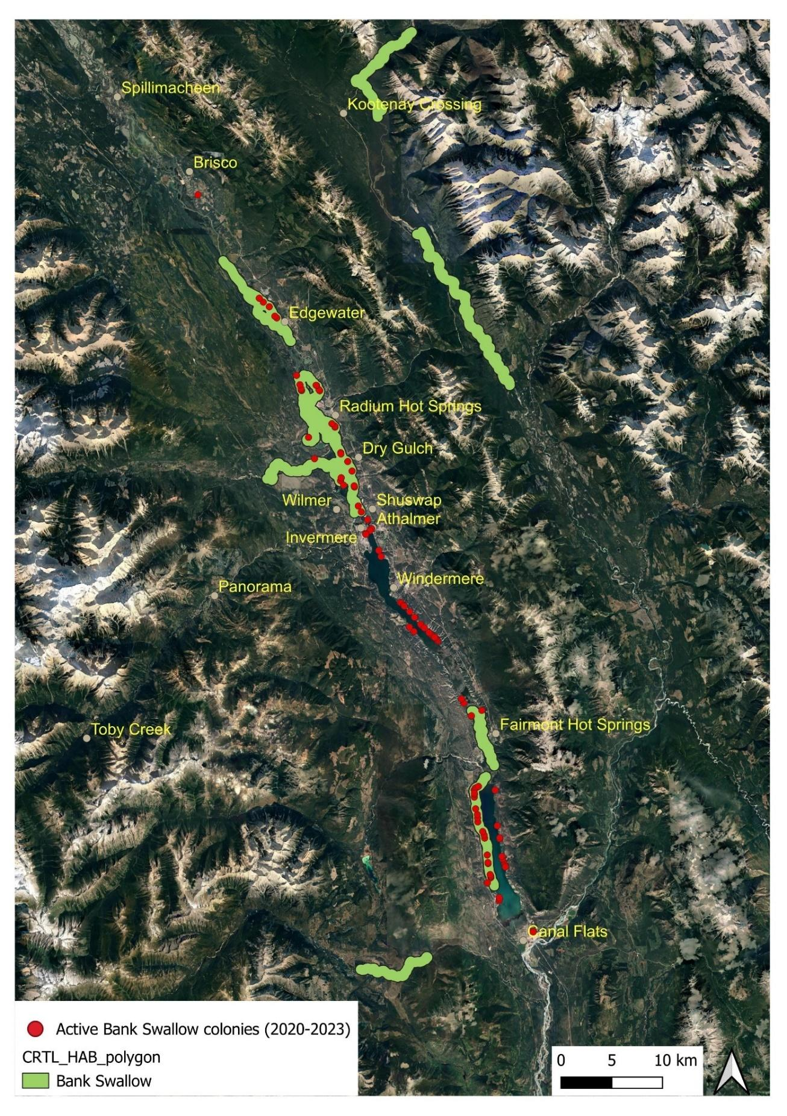
Figure 1. Map with Bank Swallow colony locations and federally designated Critical Habitat in the study area.

2.0 Goals and Objectives and Linkage of FWCP Action Plans and specific

Action(s)
The UCSHEP most closely aligns with the FWCP Wetland and Riparian Action Plan, on habitat-based action #37 - Improving available wetland and riparian areas by creating or enhancing wildlife habitat features/structures for swallows. Two artificial nest structures (ANS) for Barn Swallows were erected in year three (2023-24) (seven in total since 2021). Available wetland/riparian areas were improved by creating and enhancing at-risk Barn Swallow breeding habitat with 18 additional nest cups installed on ANS and pre-existing structures in 2023 (89 nest cups since 2021). Effectiveness monitoring at all structures has and will continue to occur until 2026. Enhancing Bank Swallow habitat occurred in the Invermere (Athalmer) area in partnership with the District of Invermere in October 2023, and an innovative bat/swallow condo was built in Parson in a collaboration with the Wildlife Conservation Society and Lake Windermere District Rod and Gun Club. An additional Barn Swallow ANS was built in Golden in October 2023.

Secondarily, the project most closely aligns with the Rivers and Riparian Action Plan, priority action 6. This is a habitat-based action working on the connectivity of habitat (for Bank and Barn Swallows). Utilizing 125 volunteers since 2021, significant Bank Swallow breeding habitat has been identified in the region. Some sites are under threat and there is a lack of suitable breeding habitat north of Brisco. Creating/restoring Bank and Barn Swallow breeding habitat in the North Columbia produces more contiguous breeding habitat patches helping facilitate connectivity networks for these species that are facing severe population declines with limited habitat. A combined approach where connectivity and overall habitat areas are enhanced across the landscape is necessary to meet long-term conservation objectives for at-risk swallows. The five-year project is working on habitat enhancement at multiple sites in the East Kootenay and North Columbia leading to more large-scale habitat connectivity for two at-risk swallow species.

3.0 Study Area
The UCSHEP study area is in the Columbia Valley located in the East Kootenay and North Columbia FWCP regions between Canal Flats and Donald (50°51'37.31"N, 116°20'12.06"W) in southeastern British Columbia (BC), Canada. The valley bottom contains one of the largest contiguous wetland complexes (Columbia Wetlands) within the southern interior of BC (Hammond, 2007). These wetlands are an important refuge for species that rely on wetlands for important stages of their life history (Darvill, 2020a) and are designated with Ramsar status which is a designation that acknowledges this wetland system has international significance.

Swallows rely on wetland ecosystems because of the abundant food supply produced (e.g., mosquitoes, midges, dragonflies). The Columbia Wetlands play an important role as migration stopover habitat for swallows and many other bird species (Darvill, 2020a; Kaiser, McKelvey & Smith, 1977). The wetlands also provide a refuge for birds to forage, feed and rest during long migratory flights that require substantial amounts of energy. The Columbia Wetlands provide vital habitat for a number of additional wildlife species including ungulates, mammals, amphibians, reptiles, invertebrates, fish and plant species, several of which are at risk (Darvill, 2020b). The area is part of the traditional and unceded territory of the Ktunaxa Nation (Akisqnuk First Nation), Secwepemc First Nation (Shuswap Band) and current home to the Metis Nation Columbia River Society.

4.0 Methods

Project start-up
- Hired local contractor to build 2023 artificial nest structures (ANS). Found contractors to do additional work scheduled to occur in 2024, and developed plans for 2024 enhancement work.
- Ordered building materials.
- Worked with the Wildlife Conservation Society’s (WCS) bat program to design a structure that satisfies habitat requirements for bats and swallows (Barn and Cliff Swallow). Collaborations with the Lake Windermere Rod and Gun Club who built/erected the bat/bird condo, called the Parson Air B&B. Subsequently hired a contractor to work on additional features (insulated roof and extension).
- Continued dialogue and site visits with landowners regarding ANS placement.
- Continued communications with the Shuswap Band regarding opportunities for additional member engagement and participation in the project. The Shuswap Band allowed for continued monitoring on their land along with Motus tagging at that site in 2023 and they continue to host Motus Wildlife Tracking Station with ECCC.
- Made updates to, and printed two more interpretive metal signs to accompany additional structures and enhancement projects that went up in 2023. One sign is a combination sign for bats and swallows made with WCS.
- Created and distributed a poster and social media posts to solicit public information regarding new nest sites for Bank and Barn Swallows on public and private lands. Posters also requested volunteers to monitor swallows.
- Got all of the data forms, protocols and waivers ready for volunteers. Had volunteers sign waivers. Coordinated them to go to specific nest or colony sites for monitoring.
- Coordinated and met with the president of the Lake Windermere District Rod and Gun Club to acquire 25 additional nest cups they built in 2023 for the UCSHEP project.
- Liaised with all partner groups to ensure effective communication and collaborations during the project, including work with ECCC CWS, The Nature Trust of BC (TNTBC), Ducks Unlimited Canada, Wildlife Conservation Society (WCS), BC Parks, Columbia Wetlands Stewardship Partners.
- Drafted landowner agreement for ANS and enhancement work, subsequently had signed.

4.2 Field Work
- Met with building contractors to ensure artificial nesting structures were erected in the chosen locations.
- Met with private landowners who received an ANS to determine precise locations for building. Due to challenging terrain to get materials to one of the sites for ANS construction, Wildsight’s Climate Youth Corp assisted with moving the materials to the building site.
- Site visits with TNTBC and WCS about potential ANS to be built on TNT owned property in Edgewater, or the option to improve structural integrity of a Quonset structure already in place that had bat and Barn Swallow occupancy. Subsequently developed plans to repair that Quonset structure (construction in 2024).
- Continued work on the Birchlands Creek restoration project for Bank Swallows that had been delayed since 2021 due to a number of various permitting issues and changing government requirements. Had an archeological assessment done, application for Section 11 water notification application, lands act permission, developed site plan and maps, Indigenous consultation request made, coordination with CPKC Rail for work in their Right of Way.
- Monitored subset of Bank Swallow colonies and Barn Swallow nests in the region; coordinated volunteers to assist. Barn Swallow nests were monitored weekly (mid-May to mid- August), Bank Swallow colonies were monitored three times during the breeding season (mid-June - July).
- Coordinated with landowners to install nest cups on pre-existing structures on private land, and on artificial nest structures.
- Motus - worked with ECCC. Used mist nets to capture, measure, remove feather samples (for stable isotope analysis that ECCC is doing) and tag/band. Captured birds were from colonies on Shuswap Band land and Columbia National Wildlife Area – Wilmer Unit.
- 'Seeded' one ANS with Barn Swallow mud nest to try and encourage Barn Swallows that this would be a good structure to nest in.
- Worked with Lake Windermere Ambassadors and Columbia Lake Stewardship Society to monitor a subset of natural colonies at Lake Windermere and Columbia Lake.
- Collaborations and work with ECCC, CWS and TNTBC to install Motus Wildlife Tracking Stations.
- Worked with BC Parks to maintain the Motus Wildlife Tracking Station that we installed at Windermere Lake Provincial Park in 2022. Also monitoring Bank Swallows at that park and did additional restoration work at a colony there; follow up to work we did with BC Parks in 2021 (Darvill, 2022).
- Built on collaborations for swallow conservation with site visits to Golden Mill, District of Invermere (DOI) at Athalmer, and Golden Concrete (in Horse Creek); they were interested in swallow enhancements and educational signage on their respective lands.
- Worked with DOI to use heavy equipment and operators to re-slope a large dirt pile in Athalmer, creating Bank Swallow habitat.
- Collaborated with Ducks Unlimited Canada (DUC) about the potential for building a Bank Swallow ANS at Moberly Marsh near Donald. This parcel was recently purchased by DUC and they are working on a wetlands re-naturalization project there. The ANS will be built in 2024.

4.3 Data collection

4.3.1 Bank Swallow inventory and monitoring protocol
To provide information on the number of active breeding pairs at colonies, the UCSHEP aimed to monitor a subset of Bank Swallow colonies at least three times per year. When possible, three surveys occurred during the following survey windows and were evenly spaced apart: first visit occurred second week of June, second visit was fourth week of June to the first week in July, and third visit was the second to third week in July. It was easier to get information on nest occupancy when the birds were feeding young (about 20 days after clutch initiation), which was the second to third week of July. If it were only possible to visit a colony once per year, this was done during the second or third week of July when adults are actively feeding chicks. If two surveys could be done, they occurred roughly between late June and mid-July.
Monitoring methods and standard field data sheets were provided to volunteers in digital format or hard copy format, whichever was preferred. Volunteers were required to sign two waiver forms, and review monitoring protocols and data forms prior to conducting surveys in the field. A Bank Swallow colony record form (developed by Bird Studies Canada but modified by UCSHEP) was completed at each Bank Swallow colony site with the following information recorded: date, time, geographical (UTM) coordinates (using a GPS in NAD83), photo documentation (yes/no), site access, colony habitat type, dominant habitat features, breeding evidence, number of pairs and active nests, and total burrows observed. Comments included any useful information about the colony, site, or habitat, as well as other burrow-nesting species seen at the colony [e.g., Northern Rough-winged Swallow (Stelgidopteryx serripennis), Belted Kingfisher (Megaceryle alcyon)] and the habitats being used by foraging Bank Swallows. Colonies were viewed from a distance, to reduce colony disturbance, but close enough to be able to view burrows.
When counting burrows, every attempt was made to count only those that appeared to be recently constructed (generally within the current breeding season). Slumped and deteriorated burrows were presumed to have been created in previous years. At colonies that were monitored more than once, a photograph of the colony was taken during the first site visit, subsequently printed, and taken into the field for the second and third monitoring periods. These photographs were used in the field to document active burrows: a burrow was circled on the colony photograph when a Bank Swallow was seen flying in or out of it or if chicks were seen at the burrow entrance. An active nest was defined as a burrow from which an adult was seen to enter or exit from or as a burrow that had nestlings visible at the entrance. On the colony photo ‘map,’ it was also indicated where other species were seen entering or exiting a burrow, such as a kingfisher or Northern Rough-winged Swallow. Volunteers were advised to spend a minimum of 30 minutes at each colony. All data that was transcribed onto the Bank Swallow colony record forms in the field was subsequently entered into an excel database. All field data collected related to colony monitoring and site descriptions were transcribed into digital databases and submitted to the provincial government (wildlife species inventory – WSI).

4.3.2 Barn Swallow monitoring protocols
Barn Swallow nest site monitoring took place during the breeding season from early May until late August. Volunteers were requested to visit nest sites on a weekly basis to obtain continuous data, but the frequency of monitoring varied based on volunteer availability and capacity. When necessary, the project biologist ensured that all nest monitoring activities were undertaken with the landowner’s permission and that any necessary authorizations were obtained. Barn Swallow nest monitoring followed protocols developed by the British Columbia Swallow Conservation Project (n.d.).
Volunteers signed waiver forms ahead of participating. They received a monitoring protocol and standard field data sheet provided in digital format; hard copies were also available upon request. Volunteers were required to review monitoring protocols and data forms prior to conducting surveys in the field. For each monitored nest site, volunteers were asked to record the actual or estimated arrival and departure date of Barn Swallows to that nest site, if possible. The activity at each nest present was recorded as best as possible. Volunteers were asked to survey nests once per week and from a distance to avoid any negative effects associated with disturbance. If nests were deemed as inactive, then this status was recorded.
During each nest monitoring visit the following details were recorded: nest attempt if known (1, 2, 3), survey date, nest condition (new nest, reused nest, damaged nest), nest activity (e.g., courtship, alarm calls, nest building, adult flushed from nest, nest with young seen or heard, nest occupied, unknown nest use, etc.), nest with young seen or heard (if known), nest disturbance (e.g., predation, human disturbance - intentional, human disturbance – unintentional, etc.), any relevant comments, etc. All swallow nests at each nest site structure were also described once in the season, such as nest type [new, reused, old (abandoned, damaged/degraded)], location in structure (interior, exterior), support structure (horizontal ledge, vertical wall (no ledge), horizontal post/pole/pipe, light fixture, etc.), ledge width, ground to nest bottom, nest bottom to overhang, nest top to overhang, closest nest, visual barrier between adjacent nest, and any relevant comments. All Barn Swallow field data collected was transcribed into digital databases and submitted to the provincial government (wildlife species inventory – WSI).

4.4 Data entry and analysis
- All data was recorded onto online excel spreadsheets by the project biologist or assistant.
- Data was formatted into the provincial database standard (SPI/WSI), and submitted to the provincial government for inclusion in their WSI system.
- Spatial data was used to update shapefiles for Bank and Barn Swallow nesting locations.
- Collaborations occurred with a Cambridge University Master’s student who is analyzing and reviewing Motus Wildlife tracking data that comes in from the Motus tags deployed in 2022 and 2023 across the Canada-wide Bank Swallow migratory connectivity project. The student is also analyzing feather isotopes from feather samples taken from birds while in the hand.

5.0 Results and Outcomes

Bank Swallow
- Between 2020-2023, Wildsight Golden’s Columbia Valley Swallow Project (Darvill, 2021) and UCSHEP have discovered 171 Bank or Northern Rough-winged Swallow colonies. 115 of those colonies had breeding Bank Swallows at them during at least one of the monitoring seasons. All colonies are not able to be visited each year, and/or some colonies have not been occupied with Bank Swallows every year.
- 37 people volunteered to monitor Bank Swallows in 2023.
- 102 colonies were monitored for presence/absence of Bank Swallows in 2023
- 218 monitoring records were made at the 102 colonies.
- 64 of those 102 colonies were confirmed to be active with Bank Swallows in 2023.
- Of those 64 colonies, 50 have accurate estimates of active burrows/nests in 2023. It was not possible to get accurate active burrow/nest counts at the remaining 14 Bank Swallow colonies due to limited monitoring time, making it impossible to get accurate active burrow counts at 10 large and busy colonies. The remaining four colonies were not able to be monitored due to lack of time, but Bank Swallows were observed at those sites.
- Of the 50 active BANS colonies observed/monitored:
  - 764 active nests/burrow entrances were observed.
  - There were 7,042 total usable burrow entrances at those 50 active colonies. This means that only about 9.2% of usable burrows were occupied by nesting Bank Swallows at the 50 monitored colonies in 2023.
  - The average number of active burrows in a colony was 15, and the average number of usable holes/burrow entrances was 141 (or about 10% of usable burrows had actively breeding Bank Swallows). This does not include the 14 active colonies as described above.
- There were 7 site visits for effectiveness monitoring at Windermere Lake Provincial Park. This is the site of restoration work (re-sloping) that was done at a Bank Swallow colony in 2021 (Darvill, 2022) with additional restoration work done in October 2023.
- Progress was made towards the Bank Swallow habitat enhancement at Birchlands Creek. Archeological report, lands act approval, created detailed plans/maps, two First Nations consultations. UCSHEP will continue work on this. Waiting on completion of the Indigenous consultation before the Water Act notification permit will be approved. The site is on Provincial crown conservation lands (Columbia Wetlands Wildlife Management Area).
- A UCSHEP volunteer discovered an active Bank Swallow colony in Athalmer in 2021, in a substrate pile on land owned by the District of Invermere (DOI) (Figure 2). The UCSHEP biologist confirmed active BANS use there in 2022. On May 26, 2023, a UCSHEP volunteer saw a pair of Bank Swallows and three pairs of Northern Rough-winged Swallows that appeared to be interested in the same burrow entrance hole. Bank Swallows were not seen again after this date. On May 28 as well as June 21st there was a burrow being used by Northern Rough-winged Swallows, but this was the last time any swallows were seen at this colony in 2023. There was human disturbance to the colony; it looked like people could have been climbing on top of the hill above the colony and many vehicles were parked within 25m to the colony for much of the summer (Figure 3). The DOI had planned to remove the dirt pile as part of a plan they developed with the community (Athalmer Neighborhood Plan). UCSHEP brought the opportunity for swallow colony conservation and breeding habitat enhancement (re-sloping nesting substrate to have a near vertical face) to their attention in September 2022. In October 2023, heavy machinery worked to enhance a 4.5m tall by 16m long section of the substrate that was to be removed. This was done with heavy machinery that resloped the substrate pile to create the vertical slope that is required by breeding Bank Swallows. Figure 4 shows the pile before slope enhancement was done; Figure 5 shows what it looked like after work was completed. Fencing was installed and interpretive signage designed and in place (Figure 6 and 7). On October 4, heavy equipment was used to reslope and enhance the substrate pile to make more suitable bank swallow breeding habitat; working with DOI. Signs and a fence were installed around the colony in fall 2023 to keep humans and dogs at a safe distance. Ideally this would have been >50 meters, but the agreeable distance (with DOI) was 23 meters.
- The data on Bank Swallow colony locations and sizes in the study area was provided to the Key Biodiversity Area (KBA) Regional Coordinator with Wildlife Conservation Society (WCS) Canada. The Bank Swallow counts may meet the KBA threshold to have the Columbia Wetlands designated as a KBA; draft KBA boundaries were drafted by WCS in March 2024 for the Upper Columbia.
- Several of the Bank Swallow colonies have been observed to have at least some level of anthropogenic disturbances including carvings into substrate at colony, adjacent construction during the breeding season, increasing boat traffic causing increased in erosional wave forces on foreshore Bank Swallow colonies, increased human presence at colonies (Figures 8 and 9).
It is important to note that the railway runs very close to many of the Bank Swallow colonies, However, since the train traffic is predictable along the exact same route, birds may be desensitized and habituated to trains to some degree although at some colonies they have been noted to leave the area when trains go by. Also, some colonies occur in quarries which can be very loud, but quarry traffic is often limited to certain areas away from active colony locations.

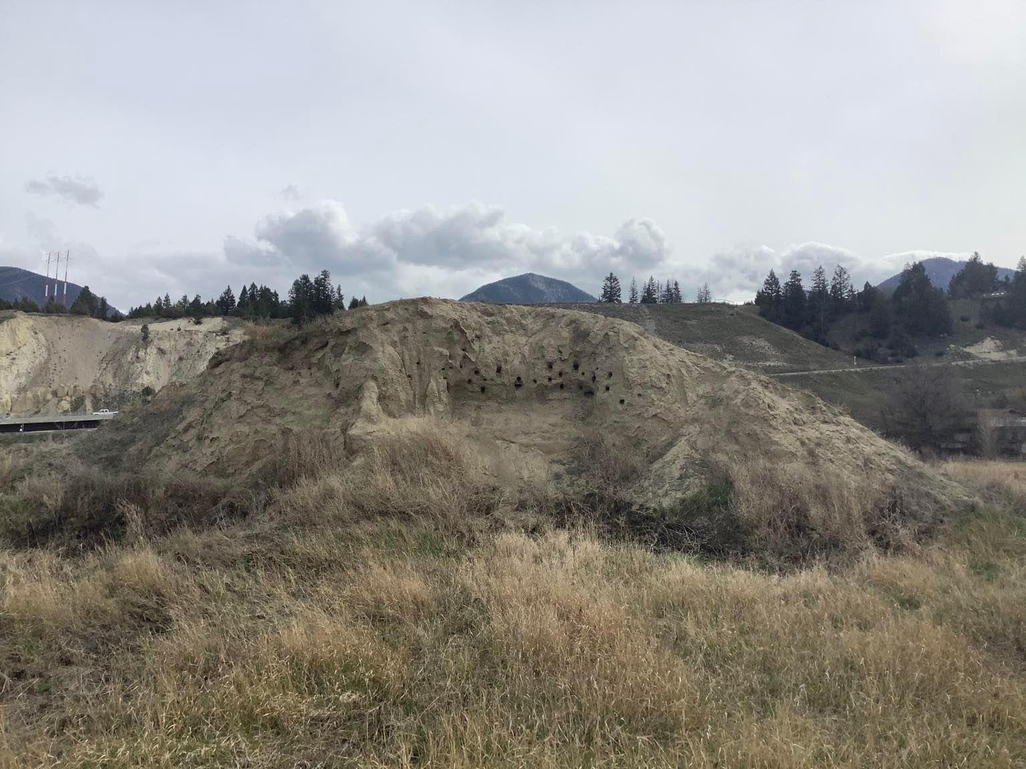
Figure 2. Active Bank Swallow colony discovered at Athalmer Neighborhood Park in 2021.

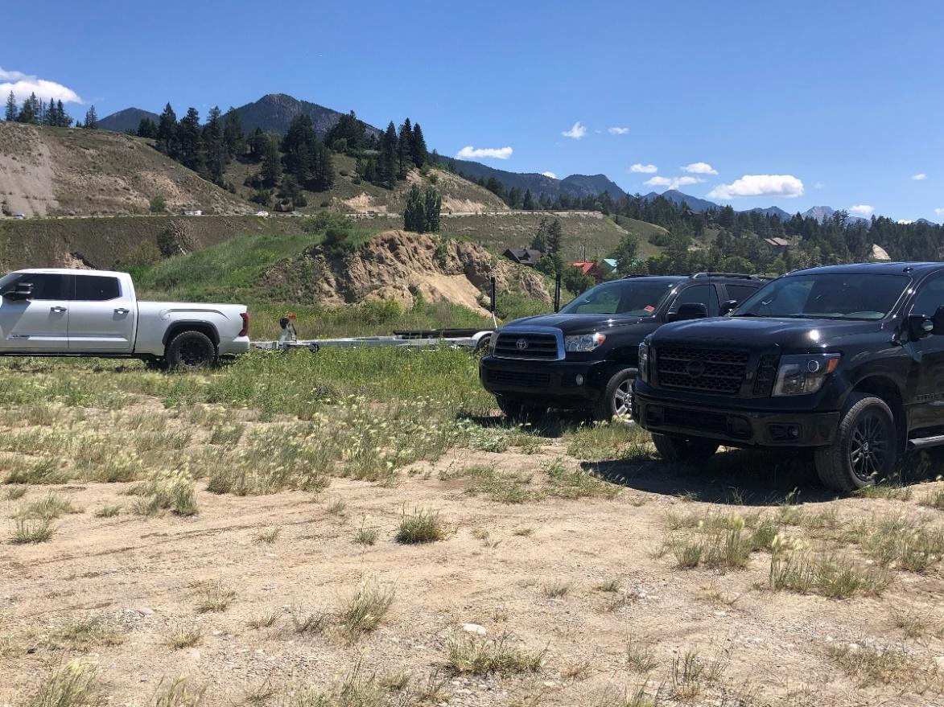
Figure 3. Vehicles and boat trailers parked within 25 meters of Bank Swallow colony in Athalmer.
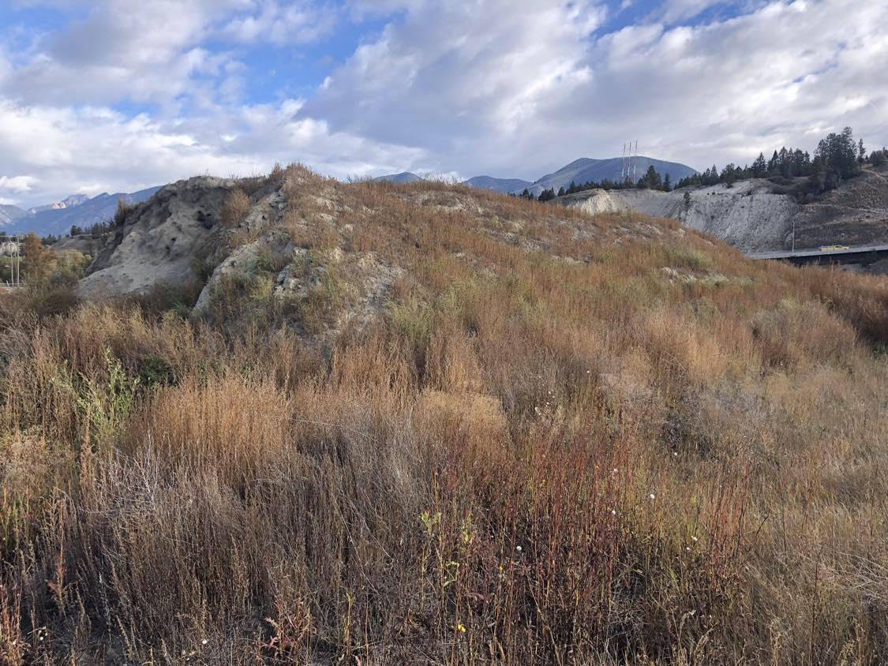
Figure 4. Substrate pile in Athalmer before resloping to expand suitable Bank Swallow habitat; active colony area on left hand side of pile.

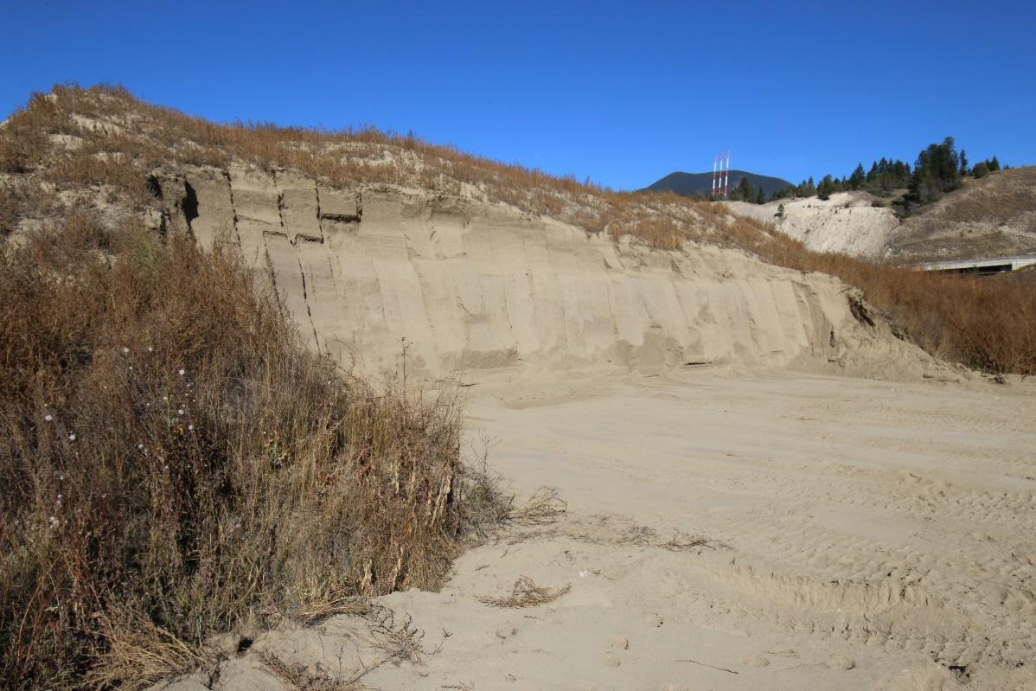
Figure 5. Substrate pile in Athalmer after resloping work had been completed by heavy machinery.

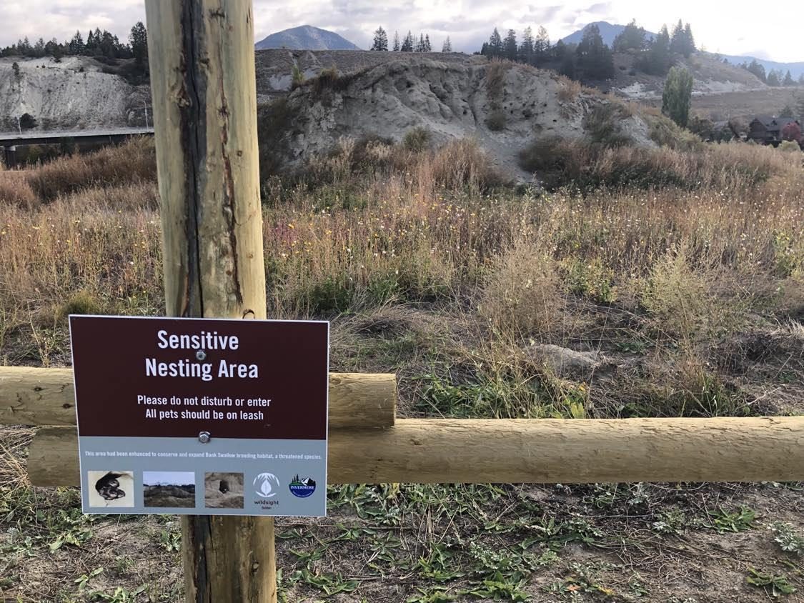
Figure 6. Signs installed on fence that was put up to inform the public of the importance of the sensitive nesting habitat in Athalmer.

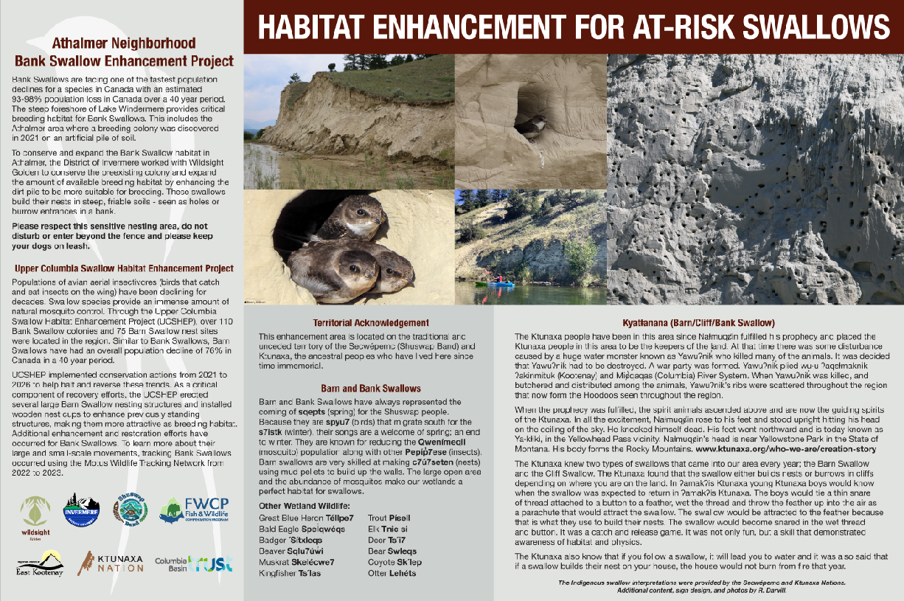
Figure 7. Interpretive sign installed at the Athalmer Bank Swallow colony in Invermere.
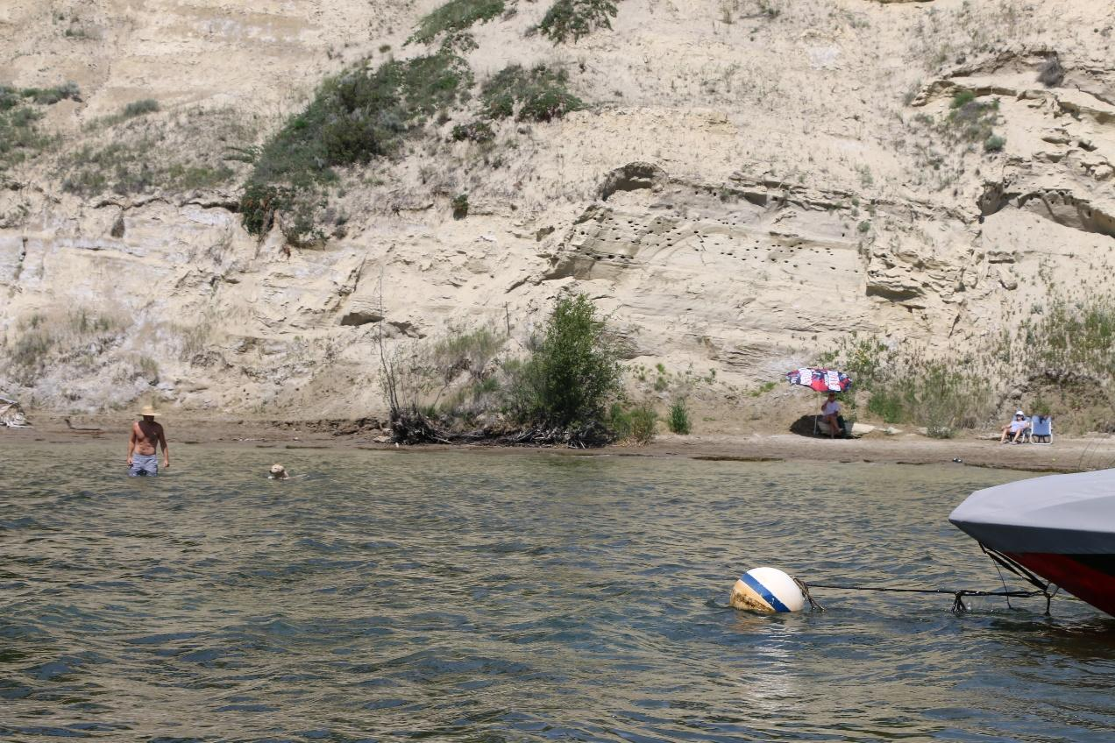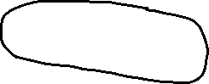
Figure 8. Sunbathers and moored boat in front of active Bank Swallow colony at Lake Windermere in June 2023. Colony circled in black.

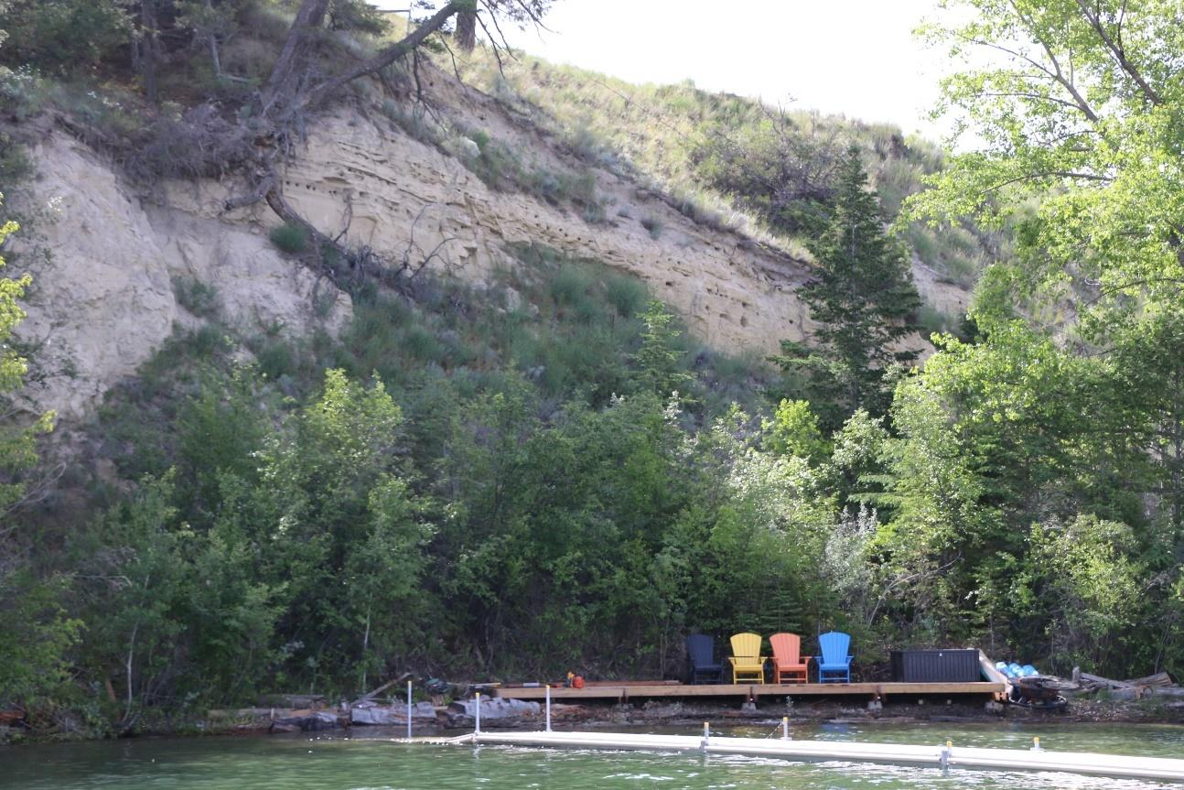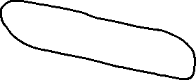
Figure 9. Abandoned Bank Swallow colony above foreshore development at Lake Windermere. Colony circled in black.
a) 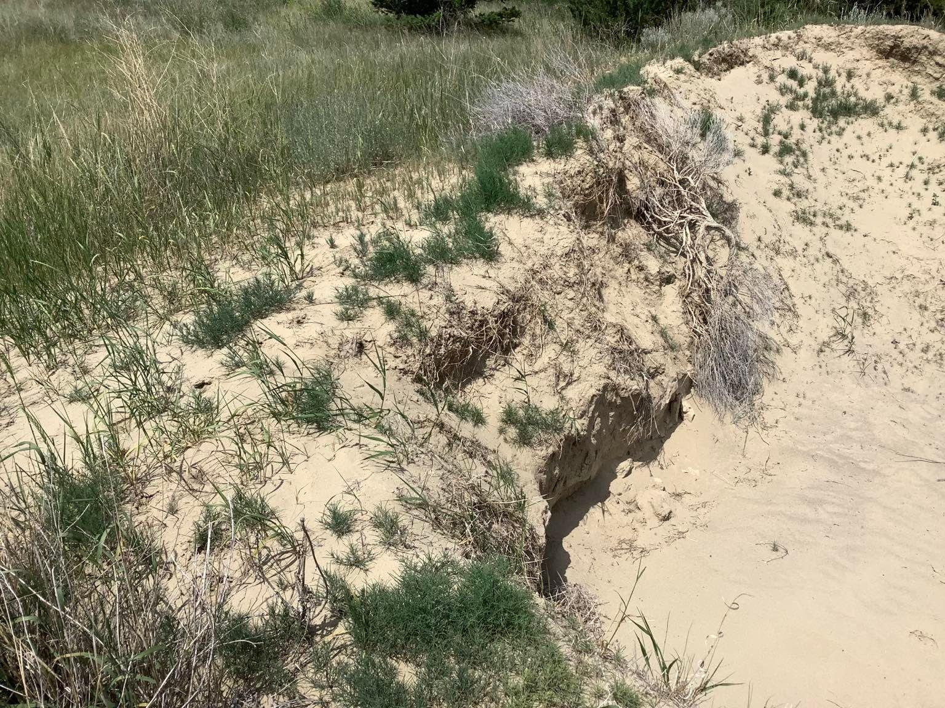
b) 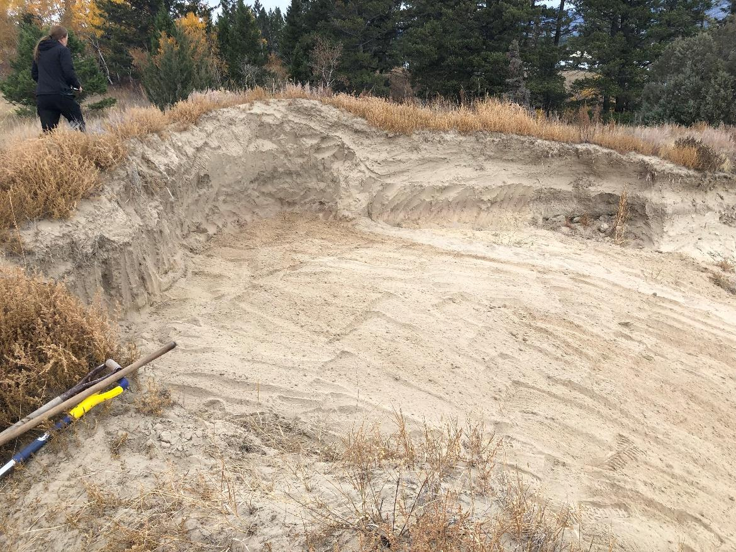

Figure 10. Bank Swallow breeding habitat at Lake Windermere Provincial Park; a) before restoration and b) after.

5.1.1 Motus Wildlife Tracking – Bank Swallows
- Collaborations with Environment and Climate Change Canada’s (ECCC) Canadian Wildlife Service (CWS) and The Nature Trust of BC (TNTBC) to install three mini-Motus Wildlife Tracking Stations in the region (Figure 11). This was in addition to the three large and one small stations installed the previous year in 2022. These stations have helped provide unprecedented information on post-breeding habitat and the Bank Swallow migration route.
- Worked with BC Parks to maintain the Motus Wildlife Tracking Station installed at Windermere Lake Provincial Park in 2022.
- With mist nests set up at two Bank Swallow colonies (Wilmer National Wildlife Area and Shuswap Band land), UCSHEP captured, tagged and banded 50 Bank Swallows with Environment and Climate Change Canada.
- Two of the tagged Bank Swallows from 2022 were last detected in Costa Rica before their batteries died in fall 2022; it appears those swallows overwintered there. Additional results from the 2022-23 Motus work and feather analysis is forthcoming from the Cambridge University student. A scientific publication is expected.
- The two years of tagging of Bank Swallows under the UCHSEP [as part of the large-scale Canada-wide initiative run by (ECCC)], was completed in 2023. ECCC left one of their large Motus stations up on Shuswap Band land, located north of Invermere. This is so that ECCC can continue to be part of the collaborative Motus network in the Columbia Valley, and also in case future Motus projects come forward in the area. They are currently investigating another potential Motus project for the Kootenays. BC Parks continues to host the Motus Wildlife Tracking Station at Windermere Lake Provincial Park.

- 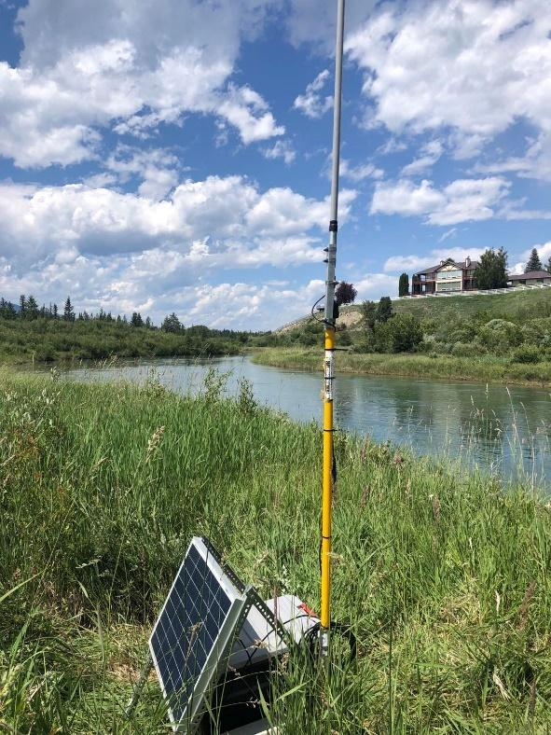 b) 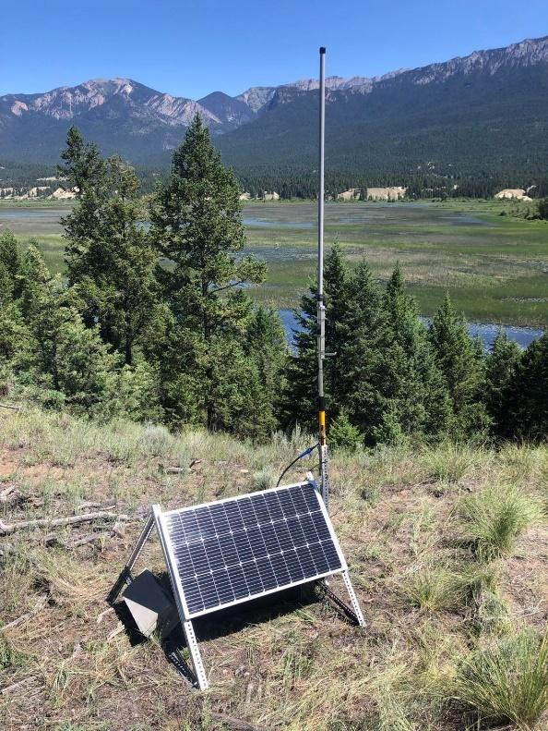
Figure 11. Mini Motus (Omni) stations installed at The Nature Trust of BC properties:, a) Columbia Lake North Wetlands property, and b) Hoodoos property.

5.2 Barn Swallow
- In total, 62 Barn Swallow nesting sites with 113 structures have been located since 2021.
- In 2023, 613 monitoring events took place by 38 volunteers and 2 staff members. 95 of the structures were monitored for Barn Swallow use and activity, including the five ANSs that were built in previous years.
- 187-188 active Barn Swallow nests were located, with 110-112 of those known to be successful.
- Reasons for unsuccessful nests - There were several sites with nests that had been newly built, but never used beyond that, but earlier those nests were considered active. For instance, the Blaeberry School Road structure had four newly built nests, but only one was used and produced fledglings.
Other nests were used, but later abandoned; especially at larger swallow colonies like Kicking Horse Mountain Resort. It was impossible to know if Barn Swallows just nested at another nest nearby at Kicking Horse, as there were many nests and many places/structures to nest. One nest was used and then disappeared before it was deemed successful. One nest was removed soon after being built. At three nests no chicks were ever seen, but could have been successful. At least one nest had a predation event.
- Two artificial nest structures (ANS) for Barn Swallows were built, one in Golden (Figure 8) and one innovative ANS that is a combination Barn Swallow/Bat structure (Parson Air B&B), thought to be the first of its kind, in collaboration with Wildlife Conservation Society Canada (Figure 9, Appendix 10.1).
- For the Parson Air B&B, an archeological assessment and Indigenous consultation was completed, along with the necessary permit/approval needed to build on the Columbia Wetland Wildlife Management Area.
- Eight Barn Swallow inventories were conducted on private land, including two for local Golden area companies (Golden Concrete and Golden Mill – Pacific Woodtech).
- 18 nest cups for Barn Swallow nesting were provided to four individuals and one Golden area company.
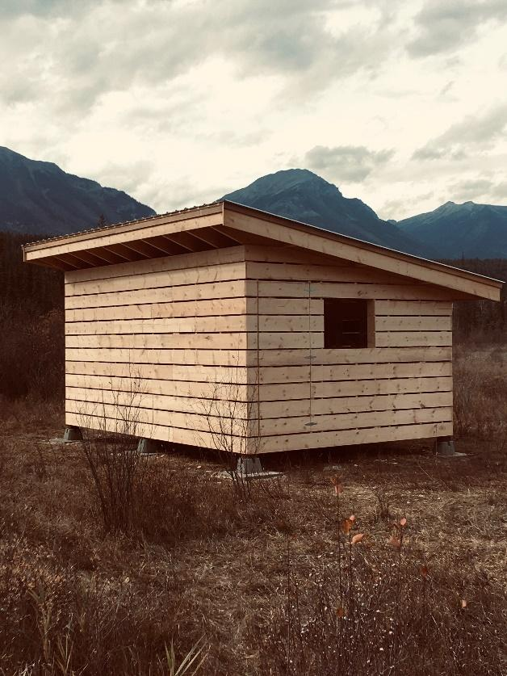
Figure 12. Artificial nesting structure for Barn Swallows built in Golden in 2023. 12' x 18' with slanted roof and low amount of openness.

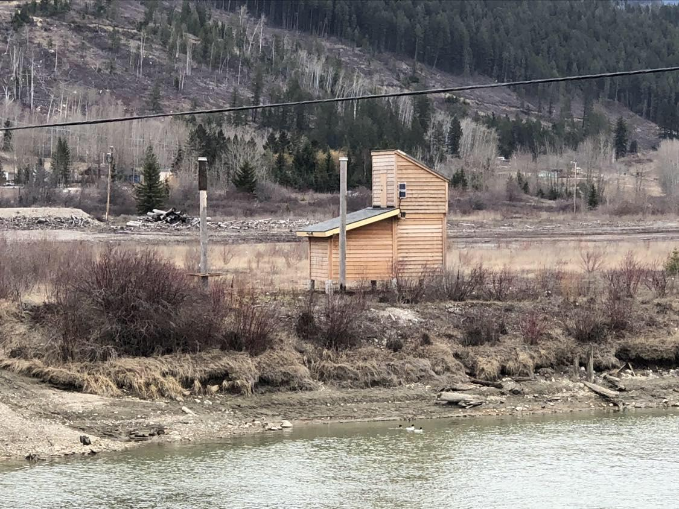
Figure 13. Parson Air B&B - an artificial nesting structure for bats and birds (swallows), located in Parson adjacent to the Columbia River within the Columbia Wetlands Wildlife Management Area.

5.3 Outreach and Education
- Three presentations were given by the program biologist including one at a Wings Over the Rockies Nature Festival (WOTR) event, one at the Columbia Wetlands Stewardship Partners AGM, and one online webinar put on by FWCP.
- UCSHEP’s program biologist led two field trips: one WOTR event at a local wetland with 20 participants and the other was for the Kootenay Conservation Program’s (KCP) Columbia Valley Local Conservation Fund with 12 participants (regional and municipal leaders).
- A wooden sculpture was given to the UCSHEP by a Golden area artist to use as a raffle prize and raise money for the project, high social media presence was used to promote the raffle.
- Seventy UCSHEP volunteers were trained on how to monitor swallows in the field, record and submit data.
- Nine land owners/managers were contacted and gave permission to have swallow surveys on their land.
- Two stories/press releases were written about the UCSHEP: one was by KCP about the swallow /bat ANS (Appendix 10.1) and one was by Wildsight Regional. The former was printed in BC Field Ornithologist’s BC Birding magazine.
- Three press releases were sent to local newspapers on the following topics: a callout for swallow monitoring volunteers, Athalmer Bank Swallow Habitat Reshaping Project (Appendix 10.2), and the year in review for UCSHEP.
- Wildsight Golden’s UCSHEP webpage content was updated twice.
- Three eBlasts about the UCSHEP were submitted through the monthly Wildsight Golden members email and 26 Wildsight Golden Facebook posts were created.
- Six posters were created and distributed regarding looking for volunteers, a raffle poster, and Barn Swallow education poster that was used at two local industry facilities to education their staff about the Barn Swallows nesting at the facilities and their status including nest protection during the breeding season (Appendix 10.3)
- An event booth/table was set up at one Golden Farmer’s Market.
- Three small (Yagi) Motus Wildlife Tracking Stations were set up in the Columbia Valley; two with assistance from the Nature Trust of BC on their Hoodoos and Columbia Lake North properties.

5.4 UCSHEP Enhancement and Restoration Projects
Since the inception of the UCSHEP, 22 enhancement projects have been completed, five more are in progress and will be completed in 2024-25 (Figure 14). A list of completed works including what type of enhancement occurred at each site and the rationale behind that work is shown in Tables 1 and 2. The map that accompanies this table shows where each project (or site) occurs on the landscape. This map also provides an overview for where future enhancement projects are expected to take place, in addition to where Bank and Barn Swallow nesting sites have been discovered in the UCSHEP study area.
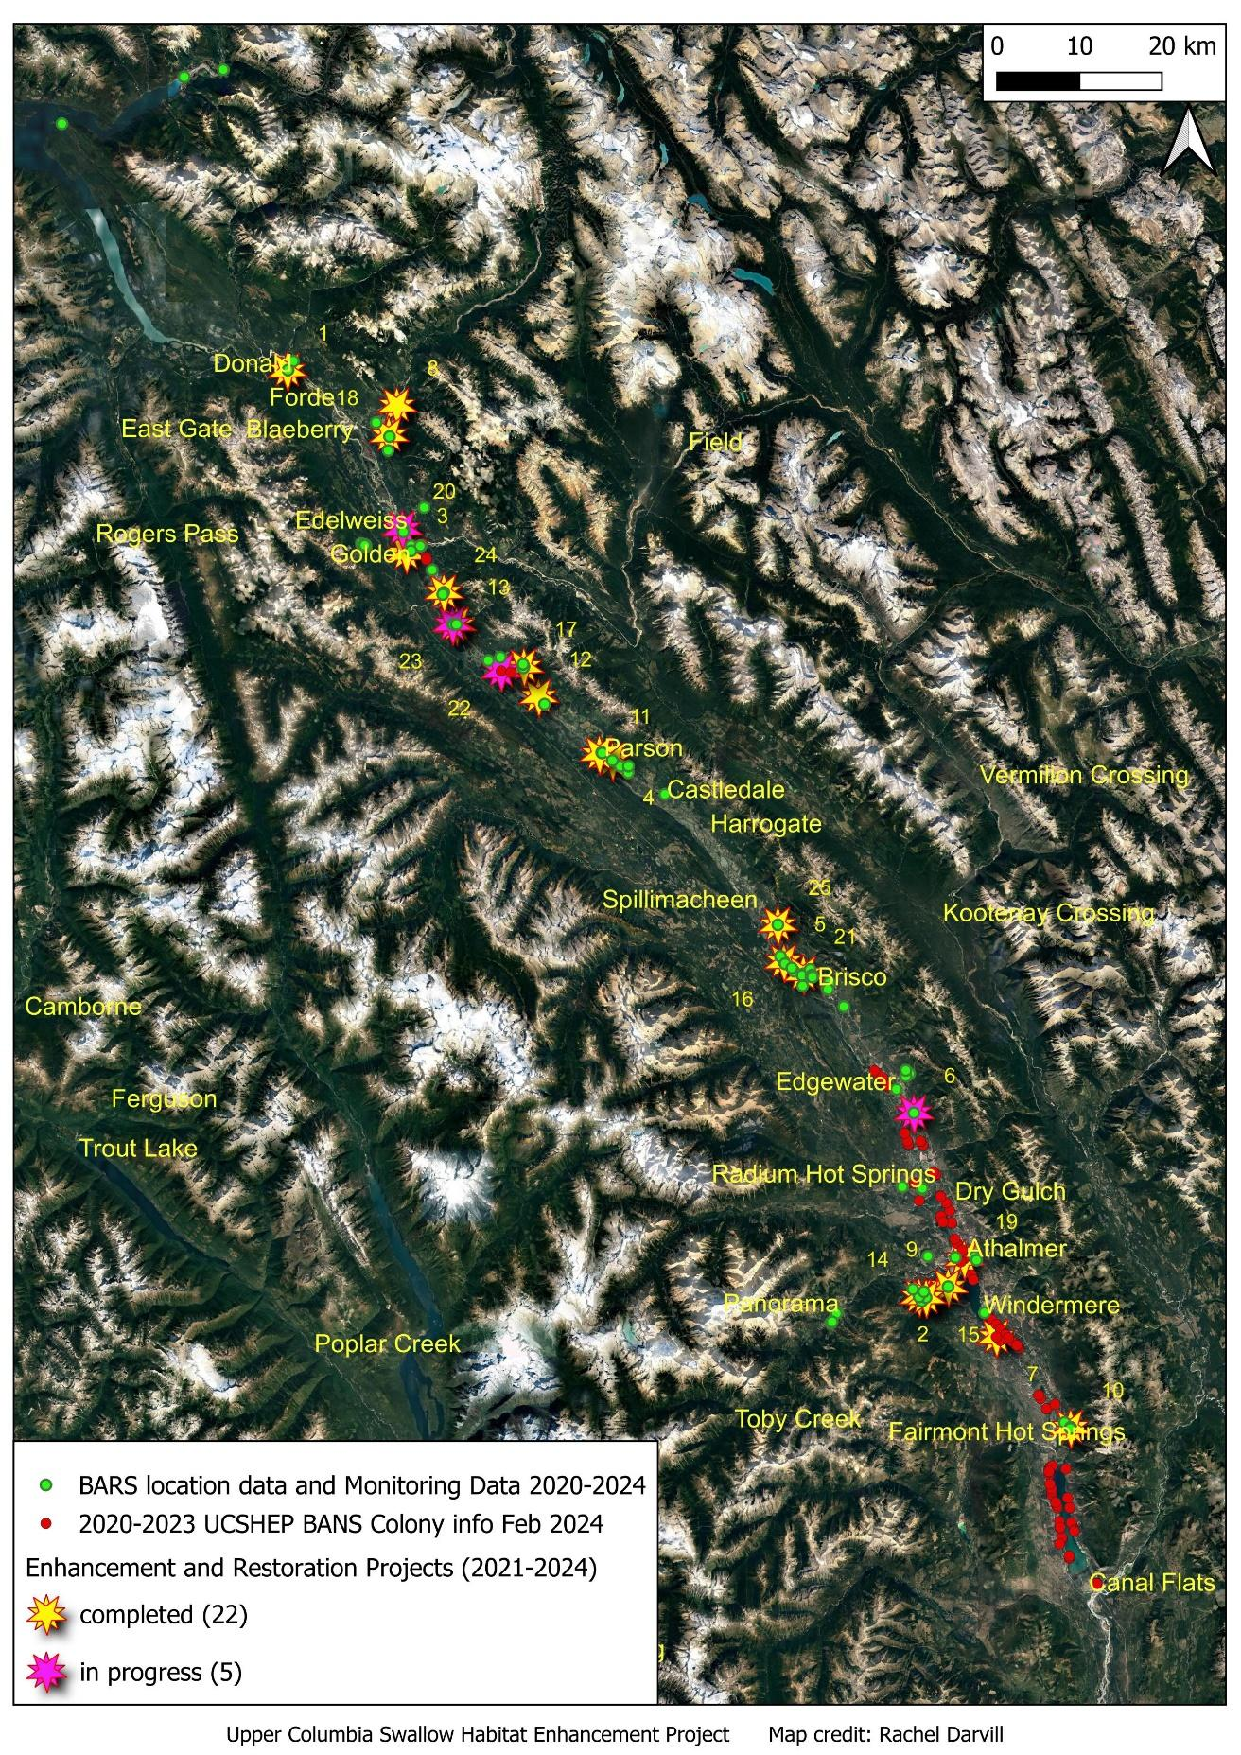
Figure 14. Map showing the locations of enhancement projects completed or in progress.
*Note – Numbers on the map align with the site numbers on Tables 1 and 2 which describes each of the projects.
Table 1. List of UCSHEP enhancement projects, completed or in progress.
Table 2. List of UCSHEP enhancement projects, completed or in progress (con't).

5.4.1 Number of hectares enhanced
Foraging distances from the nest site, during the breeding season, are roughly 500-600m for both the Bank and Barn Swallow, with some individuals foraging greater distances (>22km), especially outside of the breeding season. To determine the number of hectares enhanced or restored, a polygon was drawn around the enhanced feature with a 1-kilometer circumference around a Barn Swallow ANS (which is the distance the swallows forage during breeding). We used this area as the amount of habitat enhanced – it was enhanced by providing a structure required for swallows to breed. The polygon drawn around one Barn Swallow ANS is 75 hectares per site, so that total amount of hectares enhanced with the seven completed artificial nesting structures is 525 hectares. For Bank Swallows, two sites have been enhanced for an additional 150 hectares, totalling 675 hectares of habitat enhanced by the UCSHEP to-date. Nest cups and projects in process were not included in this assessment.

6.0 Discussion
The UCSHEP has and continues to make important contributions to conservation through habitat creation and enhancement for two at-risk species, Bank and Barn Swallows. Creating and enhancing breeding habitat for swallows expands suitable habitat areas and connectivity networks, allowing for increased swallow abundance in the North Columbia and East Kootenays. The UCSHEP is benefiting the Columbia Valley by providing education about swallows, a citizen-science opportunity to monitor swallows, erecting artificial nesting structures for Barn Swallows, enhancing slopes to create Bank Swallow breeding habitat, providing artificial nest cups for Barn Swallows to private landowners, and working with partners to help provide unprecedented information on the timing and locations of Bank Swallow movements using the Motus Wildlife Tracking System. We are also piloting a new and innovative structure (Parson Air B&B) with the Wildlife Conservation Society, to satisfy habitat requirements for bats and swallows. There are no national guidelines for building compensatory Barn Swallow habitat. The results of this project's effectiveness monitoring will help to inform future habitat enhancement/compensation efforts for Barn Swallows in B.C. and around the world.
The project has been instrumental for swallow conservation in the North Columbia and East Kootenays and has raised awareness about the importance of swallows, including their at-risk status, threats to survival, and providing information to the public on how one can help these at-risk species. Involving 125 volunteers to date has also increased peoples appreciation of swallows. Human interactions with birds has been linked with benefits to psychological well-being (Cox & Gaston, 2018) and can lead to a greater conservation ethic and increased sustainable behaviours.
A significant amount of data has been collected at Bank and Barn Swallow nests sites since 2021 and is available in the provincial data warehouse (wildlife species inventory – WSI). While the primary goal of this project is to create and expand breeding habitat for swallows, some of the monitoring data has been provided here and will be expanded upon in a final report prepared at the end of this five-year project in 2026. Additional benefits of the UCSHEP come from providing information regarding the Species at Risk Act and Migratory Birds Convention Act including obligations under this Act by educating private landowners regarding their duties to protect nests (the illegal removal of swallow nests on private lands is of great conservation concern).

7.0 Recommendations
Human-made habitats like artificial nesting structures are expected to contribute to supporting the breeding population and recovery of Bank Swallows, as long as appropriate stewardship measures are also in place, such as minimizing colony disturbance (COSEWIC 2013; Falconer et al., 2016a; Pelletier et al., 2022). Several Bank Swallow colonies were observed to have at least some level of anthropogenic disturbance, such as boat wakes accelerating slope erosion active colonies, nearby recreation, active parking areas, or carvings in colony substrates. Strategies should be developed to reduce those types of anthropogenic disturbances to swallows at both human-made and natural nesting habitats.
The preservation of natural nesting habitats is the most critical component to the recovery and conservation of Bank Swallows in Canada (Pelletier et al., 2022). Barn Swallow nests should also be preserved because of reduced energetic costs when a Barn Swallow can utilize nests built in previous years. The maintenance and preservation of natural Bank Swallow colony sites and Barn Swallow nests should be highly promoted with all levels of government, communities and other stakeholders.
The UCSHEP found that on average, the percentage of active Bank Swallows nests at natural habitats is low. The UCSHEP should continue to expand breeding habitat where it is limited, continue with effectiveness monitoring, continue to monitor a subset of natural colonies, and provide information on how to minimize disturbances at breeding sites to all interest groups. However, areas outside the breeding habitat could be the source of major stressors. It is hopeful that results of the Motus data will help provide direction on where to focus international efforts and collaboration for Bank Swallows.
Food is also critical to maintain for Bank and Barn Swallow recovery. Aerial insectivores rely on a healthy insect population for food and on wetland ecosystems because of their abundant food supply. The larvicide Bacillus thuringiensis subspecies israelensis (Bti) is used in the Columbia Shuswap Regional District (CSRD) portion of the Columbia Wetlands to reduce the mosquito population, and this could be having a negative effect on at-risk swallows and other wildlife species. “Target mosquitoes and affected midges represent an important food source for many aquatic and terrestrial predators and reduction of their populations is likely to result in food-web effects at higher trophic levels” (Bruhl et al., 2020). One 5-year study found significant effects of Bti spraying on abundance of reed-dwelling invertebrates serving as food to passerines, as well as on the diet and breeding success of swallows (Poulin, 2012). There are negative effects of Bti noted elsewhere, such as long-term persistence and negative effects in wetlands sprayed with Bti (Poulin et al., 2022), and disruption of the insect food web (e.g., Hershey et al., 1998). It is recommended that conversations with the CSRD occur to see if they are willing to consider using a more environmentally-friendly technique for mosquito control in the Columbia Wetlands. Collaborations and swallow data sharing should also continue with any group/organization that can assist with swallow species recovery including the Wildlife Conservation Society who develops Canada’s Key Biodiversity Area network, Kootenay Connect, land trust organizations, and all levels of governments.

8.0 Acknowledgements
I acknowledge that this project takes place on the unceded and traditional territory of the and Ktunaxa,
Secwépemc Nations. Gratitude to the Shuswap Band (Secwépemc Nation) who have contributed to
this project in terms of monitoring Bank Swallow colonies on band land, land access permissions, providing the Indigenous perspective on interpretive signage related to swallows, and providing permission for Motus Wildlife Tracking Stations on band land. This project would not be possible without the generous financial contributions of several groups and Wildsight Golden graciously acknowledges the financial support of the following: Columbia Basin Trust Ecosystem Enhancement Program, Fish and Wildlife Compensation Program, Regional District of East Kootenay’s Local Conservation Fund, the Province of British Columbia Gaming Grant and BC Parks Licence Plate Program. The project would also not be possible without the work and volunteer contributions of many volunteers. Special thanks to Verena Shaw, program assistant to the Upper Columbia Swallow Habitat Enhancement Project (UCSHEP) who contributed significantly to this project. I’d like to thank Wildsight Golden branch manager Leslie Adams and the entire team with Wildsight Golden, Wildsight Invermere and Wildsight Regional that assisted with various funding, administrative and communication aspects of this project. Thank you to Chloe Boynton of ECCC Canadian Wildlife Service who was the lead for the second year of Motus tagging field work. Gratitude is also extended to the Lake Windermere District Rod & Gun club who provided the UCSHEP with Barn Swallow nest cups.

9.0 References
Berzins, L., R. Clark, K. Kardynal, E. Krebs, N. Mahony & C. Morrissey. (2020). Research, conservation and outreach priorities for conserving aerial insectivore populations in Canada: Report from March 2020 aerial insectivore workshop in Saskatoon, SK.
BirdLife International. (2022). State of the world’s birds 2022: Insights and solutions for the biodiversity crisis. Cambridge, UK: BirdLife International.
British Columbia Swallow Conservation Project. (n.d.). Nest description and monitoring. Available: https://bcswallowconservationproject.wordpress.com/nest-monitoring-and-research/
Brühl, C. A., Després, L., Frör, O., Patil, C. D., Poulin, B., Tetreau, G., & Allgeier, S. (2020). Environmental and socioeconomic effects of mosquito control in Europe using the biocide Bacillus thuringiensis subsp. israelensis (Bti). Science of the total environment, 724, 137800.
COSEWIC. (2011). COSEWIC assessment and status report on the Barn Swallow (Hirundo rustica) in Canada. Committee on the Status of Endangered Wildlife in Canada. Ottawa. ix + 37 pp. (www.sararegistry.gc.ca/status/status_e.cfm).
COSEWIC. (2013). COSEWIC assessment and status report on the Bank Swallow (Riparia riparia) in Canada. Committee on the Status of Endangered Wildlife in Canada. Ottawa. ix + 48 pp. (www.registrelep-sararegistry.gc.ca/default_e.cfm).
Cox, D. T., & Gaston, K. J. (2018). Human–nature interactions and the consequences and drivers of provisioning wildlife. Philosophical Transactions of the Royal Society B: Biological Sciences, 373(1745), 20170092. https://doi.org/10.1098/rstb.2017.0092
Darvill, R. (2020a). 2015-2019 Columbia wetlands waterbird survey. Prepared for Wildsight Golden. Available: https://wildsight.ca/wp-content/uploads/2016/01/CWWS-2015_2019-Final-Report_Jan-2-2020.pdf
Darvill, R. (2020b). Kootenay Connect: Columbia Wetlands. Literature review of species at risk in the Columbia Valley. Prepared for the Columbia Wetlands Stewardship Partners and Kootenay Connect, a project facilitated by the Kootenay Conservation Program.
Darvill, R. (2021). Columbia valley swallow project – 2020. Prepared for Wildsight Golden. Accessed here: https://d1tfm8vclpltjj.cloudfront.net/wp-content/uploads/2020/04/Columbia-Valley-Swallow-Project-Final-Report-Jan-22-2021.pdf
Darvill, R. (2022). Upper Columbia swallow habitat enhancement project – Year 1 (2021-2022). Large grant - Final report project number: COL-F22-W-3479. Prepared for the Fish and Wildlife Compensation Program.
Darvill, R. (2023). Upper Columbia Swallow Habitat Enhancement Project - Year 2 (2022-2023). Large Grant - Final Report Project Number: COL-F23-W-3680. Prepared for the Fish and Wildlife Compensation Program by Goldeneye Ecological Services.
Environment and Climate Change Canada. (2022). Recovery Strategy for the Bank Swallow (Riparia riparia) in Canada. Species at Risk Act Recovery Strategy Series. Environment and Climate Change Canada, Ottawa. ix+ 125pp.
Garrison, B. A. and A. Turner (2020). Bank Swallow (Riparia riparia), version 1.0. In Birds of the World (S. M. Billerman, Editor). Cornell Lab of Ornithology, Ithaca, NY, USA. https://doi.org/10.2173/bow.banswa.01
Hammond, B. (2007). The conservation rationale for regulating the use of navigable waters in British Columbia’s Columbia wetlands. Canadian Wildlife Service, Environment Canada. Delta, British Columbia, Canada.
Hershey, A. E., Lima, A. R., Niemi, G. J., & Regal, R. R. (1998). Effects of Bacillus thuringiensis israelensis (BTI) and methoprene on nontarget macroinvertebrates in Minnesota wetlands. Ecological Applications, 8(1), 41-60.
Imlay, T. L., Saldanha, S., & Taylor, P. D. (2020). The fall migratory movements of bank swallows, Riparia riparia: fly-and-forage migration?. Avian Conservation & Ecology, 15(1).
Kaiser, G.W., R.W. McHelvey and D.W. Smith. (1977). Preliminary report on aerial surveys in the Columbia Valley, British Columbia. Canadian Wildlife Services. In Pedology Consultants, 1983. Opportunities for Wildlife and Recreation Development in the Columbia River Wetlands. Prepared for Fish and Wildlife Branch, B.C. Ministry of Environment, National Second Century Fund of British Columbia, Ducks Unlimited Canada and Canadian Wildlife Service.
Nebel, S., A. Mills, J. D. McCracken, and P. D. Taylor. (2010). Declines of aerial insectivores in North America follow a geographic gradient. Avian Conservation and Ecology 5:1
North American Bird Conservation Initiative Canada. (2019). The State of Canada’s Birds, 2019. Environment and Climate Change Canada, Ottawa, Canada. 12 pages. www.stateofcanadasbirds.org
Pelletier, N., Arndt, J., Darvill, R., & Cyr, M. A. (2022). Natural and human-made nesting habitat use by Bank Swallow (Riparia riparia) in Canada. The Canadian Field-Naturalist, 136(3), 228-236.
Poff, N.L., Allan, J.D., Bain, M.B., Karr, J.R., Prestegaard, K.L., Richter, B.D., Sparks, R.E. and Stromberg, J.C., (1997). The natural flow regime. BioScience, 47(11), pp.769-784.
Poulin, B. (2012). Indirect effects of bioinsecticides on the nontarget fauna: The Camargue experiment calls for future research. Acta Oecologica, 44, 28-32.
Poulin, B., Lefebvre, G., Hilaire, S., & Després, L. (2022). Long-term persistence and recycling of Bacillus thuringiensis israelensis spores in wetlands sprayed for mosquito control. Ecotoxicology and Environmental Safety, 243, 114004.
Rosenberg, K. V., Dokter, A. M., Blancher, P. J., Sauer, J. R., Smith, A. C., Smith, P. A., Stanton, J.C., Panjabi, A., Helft, L., Parr, M. & Marra, P. P. (2019). Decline of the North American avifauna. Science, 366(6461), 120-124.
Scordato, E. S. C. and R. J. Safran (2014). Geographic variation in sexual selection and implications for speciation in the Barn Swallow. Avian Research 5:8.
Shanahan, D. F., C. Miller, H.P. Possingham, & R.A. Fuller. (2011). The influence of patch area and connectivity on avian communities in urban revegetation. Biological Conservation, 144(2), 722-729.
Smith, A.C., M-A.R. Hudson, C.M. Downers, and C.M. Francis. (2020). North American Breeding Bird Survey – Canadian trends website, data-version 2019. Environment and Climate Change Canada, Gatineau, Quebec, Canada.
Spiller, K. J., & Dettmers, R. (2019). Evidence for multiple drivers of aerial insectivore declines in North America. The Condor, 121(2), duz010.

10.0 Appendices

10.1 Appendix A. Newspaper article on the swallow/bat artificial nesting structure in The Golden Star in July 2023.

10.2 Appendix B. Article in The Golden Star newspaper about the completed Bank Swallow enhancement project in Athalmer.

10.3 Appendix C. Poster developed for distribution at a wood mill in Golden with a high population of breeding Barn Swallows.

